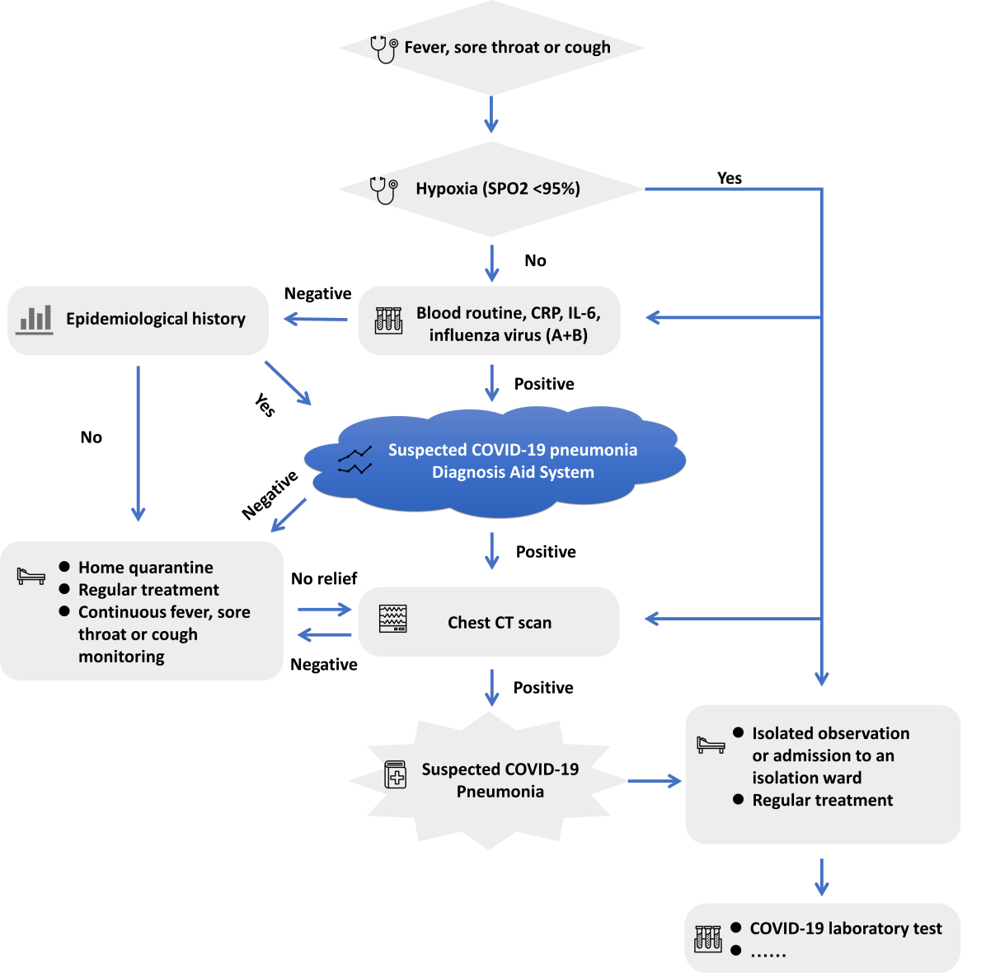

**Suspected COVID-19 Pneumonia**

**Chest CT scan**

**Suspected COVID-19 pneumonia Diagnosis Aid System**

**Blood routine, CRP, IL-6,**

**influenza virus**

**Fever, sore throat or cough**

* **Isolated observation or admission to an isolation ward**
* **Regular treatment**



* **Home quarantine**
* **Regular treatment**
* **Continuous fever, sore throat or cough monitoring**

**Epidemiological history**



**Hypoxia (SPO2 <95%)**



* **COVID-19 laboratory test**
* **……**



**Yes**

**No**

**Yes**

**No**

**Negative**

**Positive**

**Negative**

**No relief**

**Positive**

**Positive**

**Negative**